**Rural Trauma Simulation Course**

**2017**

**Filip Gilic, CCFP-EM**

**Introduction**

Rural, single provider, trauma is hard. There is a reason that trauma centres employ multiple-provider trauma teams: the number of tasks is large, priorities often contradictory and resources needed immense.

Consider an MVC victim with a belly full of beer an pizza who has a traumatic head injury with decreased level of consciousness as well as a hemo/pneumothorax with hypotension. Do you follow the ABC mantra and secure the airway with an ETT first, or do you react to the actual threat to life (hemo/pneumo) with a chest tube?

Both those tasks take time and concentration and there is a high chance by the time you finish with one, the other situation has spiralled out of control. To deal with this “more tasks then personnel” situation, you need a ruthless focus on **fixable life/brain/limb** threatening injuries and refusal to be distracted by anything else.

Since the ATLS approach is realistically geared towards the trauma-team approach, I find that some alteration is often necessary to make the protocols fit the restricted personnel and resources. This manual represents my approach in such an environment. The manual focuses on dealing only with the injuries that are both significant and that we can fix or at least influence outcomes on. Thus, injuries such as diaphragmatic tears, hollow bowel viscus injury, aorta and other great vessels tears are generally ignored as as they either usually produce rapid death in the absence of immediate OR access, or only become apparent and start influencing patient outcomes after the patient has typically been transferred out of our department.

Feel free to pick and choose parts that make sense to you and disregard the ones that don't. While the manual is well-researched, it is, of course, not exhaustive. Apply your own experience, research and common sense when using it in your particular environment. All mistakes in it are my own.

**Blunt trauma**

Majority of trauma we encounter in Canadian EDs is blunt. Good thing about that is that it is often less deadly then high energy penetrating trauma, bad thing is that the injuries are often occult and take time or high index of suspicion to become apparent.

Below is our approach to a significant blunt trauma.

**Assessment Preparation:**

If the patient is combative or moving, an assistant hold the neck and provides inline stabilization until told it is no longer necessary. Do not assume that C spine collar immobilizes the neck sufficiently- it does not.

Then, the patient is fully undressed, cutting clothing away using trauma scissors

We get a full set of vitals including temperature

2 large bore IVs are initiated, monitors are attached for ongoing vital sign measurement and 100% FiO2 is initiated

If the patient is breathing spontaneously: nasal prongs and a non-rebreather mask both at 15L+ flow

If the patient is not adequately ventilating: Jaw thrust and Bag valve mask assists with a CPAP valve, O2 turned at 15L+ flow

If possible, get an AMPLE history from EMS or the bystanders

1. Allergies

M-Medications

P-Past medical history

L-Last meal

E-Environment the patient was in when the trauma occurred

Inline stabilization

Undressing

Vitals

2 IVs-O2-monitors

AMPLE

**Airway and disability:**

In the rural environment, deciding to intubate a trauma is a big decision that ties you and your team for significant periods of time, so we will try to determine first if the endotracheal tube is truly necessary, or can we buy time with other methods:

Airway assessment is looking at 3 things:

1. Internal swelling/deformity (airway burns/traumatic swelling or intraoral injuries)

2. External swelling/deformity (neck, face or jaw)

3. Presence of blood or vomit

If any of those are present, securing the airway with an endotracheal tube becomes an unavodiable priority.

Changing Airway

Stuff in Airway

ETT airway control

If none of the above is present,

If the above are not present, we can asses for further criteria that might require some form of airway control but can now add supraglottic devices (King LT or LMA) as a form of airway control

1. Persistent apnea, or O2 sats not improving with gentle BVM/jaw thrust
2. Level of consciousness at Pain or Unresponsive on the AVPU scale (Aware-Verbal stimuli needed-Pain needed-Unresponsive).
3. Combative patient- danger to provider injury and risk of worsening

C-spine injuries. Attempt to control the situation with pain control (1-2mcg/kg of Fentanyl) or dissociative sedation (20-50mg Ketamine IV, 50-100mg IM) first

Apnea/Low O2

AVPU

Combative

SGD or ETT

*No GCS?* Glasgow Coma Scale is cumbersome, with poor interrater reliability and poorly predicts the need for intubation. AVPU is much quicker and with P corresponding reliably to GCS of 8 and U to GCS of 6 or less

A word on methods of respiratory support:

**Bag valve mask**: Provides positive pressure ventilation at the level of the mouth and offers no protection against aspiration. Thus, there is often reluctance to use it in the “belly full of beer and pizza” trauma patients. In reality, it if often necessary (at least in the short term) and, if done right, does not pose a massive risk to insuflating the stomach. The average pressure for opening the lower esophageal sphincter is 25mm H2O- it is reasonably easy to stay below such pressure by using these 3 tips:

* 1. Use the CPAP valve and turn up the O2 flow meter past 15L. This ensures true 100% FiO2 plus adds CPAP and in turn reduces the volumes you will need to generate to maintain good O2 saturations
  2. Take your time with ventilations: take at least one full second (“one one thousand”) to provide a breath
  3. Limit the amount with each breath: the BVM bag holds 1.5L of O2 and our tidal breaths are usually about 500cc so you only need to squeeze in 1/3 of the bag or less. In practice, the slowest and least aggressive BVM that holds O2 sats at 95%+ is the way to go.

*BVM without the CPAP valve: BVM with a CPAP valve:*

Allows room air to mix with 100% O2 Provides 100% FiO2 and effectively

and does not recruit the alveoli recruits the alveoli

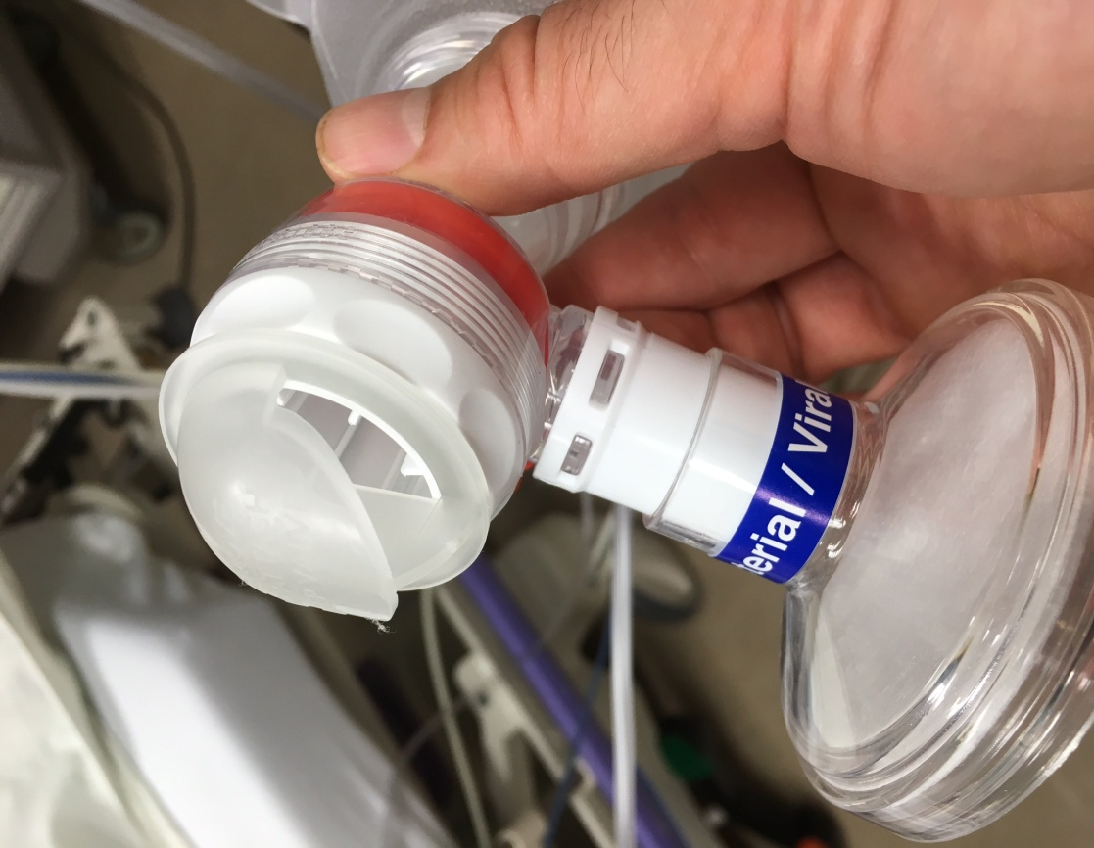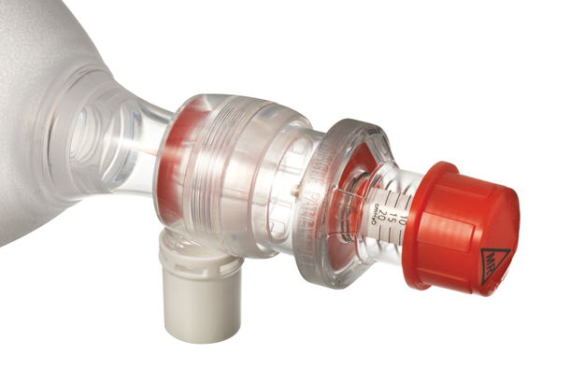

**Supraglottic devices (SGDs):** LMA or King LT. Provide positive pressure in the pharynx but above the level of the vocal cords and provide decent but not absolute aspiration protection. Unless there is active bleeding/vomit or closing of the airway a very strong alternative to an intubation as it can be placed in a fraction of time, with fraction of resources and much reduced error rate compared to an ETT. It is a great temporizing measure allowing you to continue managing other aspects of a trauma until the situation stabilizes or help shows up. They also do not require manipulation of the C-spine to be placed.

**Endotracheal tube (ETT):** provide positive pressure below the vocal cords and offer best aspiration protection. You have 3 ways of placing it: direct laryngoscopy (DL), video laryngoscopy (VL) and surgical (cricothroidothomy).

**VL**: In Canada, usually Glidescope. The advantage is that the camera within the blade obviates the need to align all the visual axis of the mouth, pharynx and vocal cord into one plane. Practical meaning is that it allows for easier visualization when you cannot put the patient in the proper sniffing position. In trauma, the usual cause of this is C spine precautions. Thus, if you need to maintain C spine precautions, use VL. The downside of VL is that the camera can be obscured by blood/vomit or secretions.

**DL:** has an easier time then VL when there are copious secretions (be it spit, blood or vomit) within the airway.

***A word on C-spine precautions***: C-spine immobilization is a “nice to have”, rather then really a must. Biomechanically, there is practically no chance of inducing or worsening C spine injury from minimal movements created by an intubation attempt. Thus, if you have real trouble visualizing the cords or placing the tube, let go of the C spine immobilization and move the head so you can see what you need to see.

***Drugs***

*If you are placing an SGD*, use induction dose of Ketamine (100-150mg IV, double that if IM) as light anesthesia is the biggest risk factor for aspiration with such devices.

*If you are placing an ETT* and not anticipating a very difficult airway, add paralysis with Rocuronium at 1.2mg/kg.

*If you anticipate a difficult airway with an ETT* do not paralyze the patient, give 20-50 mg of Ketamine IV, or double that IM and do a dissociated intubation, while having a cricothyroidotomy kit open and ready in case you fail the laryngoscopy.

**Surgical:** Use it if the VL or DL fails and/or in truly difficult airways like an oral burn. Cricothyroidotomy is a simple procedure in most (non massively obese, non larynx-injured) patients and if you are feeling skittish about doing this, remember this- in Afghanistan, crics were the primary method of airway control for compromised airways by army medics in battlefield conditions, and they did it with close to 100% success rate. In a similar vein, a large review of all airway complications in the UK showed that the scalpel/bougie method (see below) had a 100% success rate and is now the recommended primary approach for the “can't intubate, can't oxygenate” situations. In the same series, the percutaneous kits (with a wire) had 60% failure rate and this certainly makes sense from performance psychology perspective: emergency crics are a high stakes situation where the performer's stress level is going to be very high. Threading the wire and other fine-motor complex percutaneous manouvers are very hard to do in such a mental environment and they take much longer. The scalpel/bougie technique, on the other hand, can be reliably performed in 30-40 seconds.

***Scalpel Bougie Cric***

A quick 3 part procedure:

1. A vertical skin incision between thyroid and cricoid cartilage
2. A horizontal incision though the cricoid membrane, and a flip of the scalpel handle, or a curved Kelly blunt dissection to widen the hole
3. Passage of a bougie loaded 5.5 size ETT aiming inferiorly through the opening. Insert to 12-15 cm only as you are already below the vocal cords.

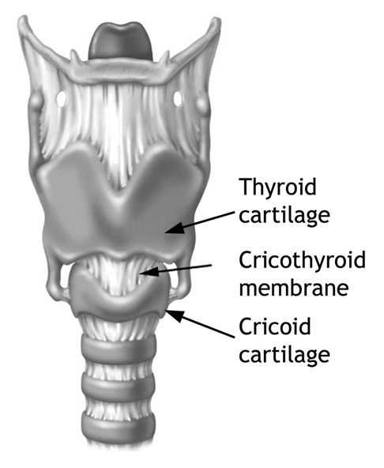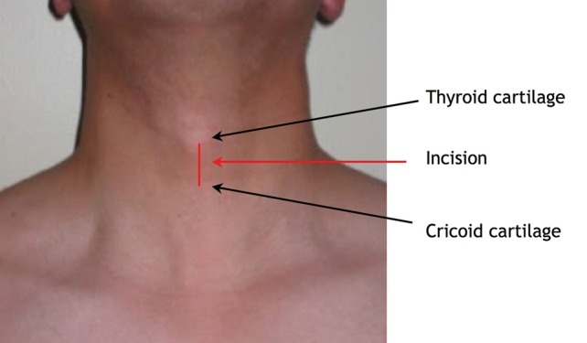

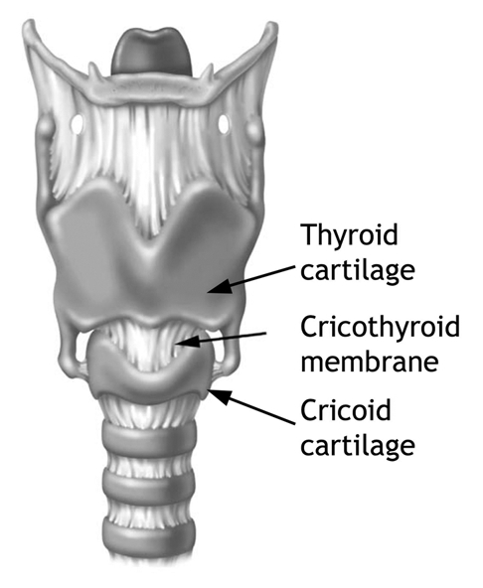

Concurrent with the airway assessment, we will do a quick Disability check

The **Disability** part also has 3 components:

**Pupils**

* + 1. unequal or sluggish means increased ICP
    2. pinpoint narcotics/benzos
    3. wide means fear/pain or sympathomymetics (cocaine, meth, etc)

**C-spine palpation**. If any mid line tenderness is detected- assume C spine fracture

**Moving all 4 limbs**: simple stuff only- wiggle fingers/wiggle toes.

The reason to do the disability step now is that if you do decide to intubate/sedate/paralyze the patient, you will lose the ability to assess such things and thus deny yourself fairly critical information. Medico legally, it also helps to establish that the patient was paralyzed or not before he came to your care.

Pupils

C spine palp

Moves 4 limbs

***Closed Head injury?***

If you suspect closed head injury from the mix of mechanism of injury, pupils and level of responsiveness you have 3 priorities

1. Prevent hypoxia as even a single episode doubles mortality. Keep SpO2 above 94%.
2. Prevent hypotension. Similar to hypoxia, even a single episode increases mortality. Keep MAP>75
3. Manage raised ICP with Mannitol, head of bed elevation and moderate hyperventilation

Overall, our A+D step follows this progression

Changing Airway

Stuff in Airway

ETT airway control

Apnea/Low O2

AVPU

Combative

SGD or ETT

Pupils

C spine palp

Moves 4 limbs

**Breathing**

Very quick step looking for only two things.

1. Palpate the chest to evaluate the presence of multiple rib fractures and especially flail chest (two or more ribs broken in two places or more- causes paradoxical breathing where chest segment goes in with inhalation) as such injuries typically require positive pressure ventilation- either though BVM, or if they are conscious and without blood in the airway, BiPAP/CPAP machine.
2. Auscultate and percuss both lungs. Decreased air entry +/- increased percussion AND respiratory distress equals immediate needle decompression or finger thoracostomy

in the affected lung for suspected pneumothorax.

Asucultate

Palpate

Percuss

Pneumo

Needle or finger decompress

Flail

PPV

**Circulation**

Now, we go on the hunt for the “7 deadly hemorrhage compartments” that can hold enough blood for the patient to potentially exsanguinate and 3 “special conditions” that can threaten life:

**Hemorrhage Compartments**

1. L chest hemothorax
2. R chest hemothorax
3. Abdomen solid viscus (liver/spleen) or blood vessels (mesenteric or anterior aorta) injury with intra peritoneal bleeding
4. Pelvic fractures with bleeding, usually from posterior venous plexus, occasionally from injured illiac vessels.
5. L femur and thigh
6. R femur and thigh
7. Retro peritoneal space (pancreas, inferior tears of aorta or iliacs, pelvic fractures) bleeding

**Special Condition**

1. Tension pneumothorax
2. Cardiac tamponade
3. Neurogenic shock from cervical or thoracic spinal cord compression. Not to be confused with spinal shock, which is a temporary loss of spinal cord function and resultant transient flaccid paralysis following acute spinal injury. Neurogenic shock occurs due to loss of sympathetic chain innervation (which runs along the spine until it reaches the lumbar spine levels) and subsequent loss of systemic vascular resistance. This type of shock is characterized with bradycardia (or relative lack of tachycardia), flushed skin due to vasodilation, hypotension that refuses to be fixed with fluids and blood and, often, lower limb paralysis.

R

thigh

L thigh

L pneumo/

hemo

Abdomen

Pelvis

R

pneumo

/

hemo

Tamponade

Back

S

P

I

N

E

*Overview of the deadly compartments. Special conditions outlined in red*

The chest compartments have already been evaluated in the breathing steps, so we add

* + 1. Heart auscultation for muffled heart sounds and look for distended neck veins
    2. 4-quadrant abdomen palpation (poor sensitivity unless repeated over a period of hours).
    3. ONE and ONLY ONE lateral compression of the hip trochanters or iliac crests, and if no movement detected there, ONE press on the symphysis pubis. If movement is detected on either manoeuvre, the patient's pelvis is immediately sheathed.
    4. Palpation of thighs for femur fracture and hematoma
    5. Roll over with C spine stabilization and palpation of C/T/L spine and observation for back deep bruising signifying potential retro peritoneal hemorrhage

***DRE?***Routine DREs in all significant trauma patient is a practice not rooted in evidence. DREs change management in only 1.2% of cases.

Consider a DRE if

1. Penetrating injuries in the GI tract area
2. Pelvic fractures
3. To confirm paralysis

***Foley?*** If there are no signs of urethral injuries (bloody meatus, perineal hematoma, high riding prostate on DRE in the presence of pelvic fracture), put the Foley in, for two reasons.

1. Presence of gross hematuria (but not microscopic) indicates presence of potential retro peritoneal blunt kidney injury.
2. Long term, it allows you to judge the degree of hypo perfusion if the patient is not producing the usual 0.5cc/kg/hr of urine.

If you have the capability, ultrasound is an excellent add-on. With U/S, we can look at 6 out of 7 “deadly compartments” (retro peritoneal is the only one where we are blind) and 2 truly deadly of the 3 “special conditions (tamponade and pneumothorax) with much more sensitivity then with the clinical exam alone. If you do not have such skills, you will have to rely on repeated clinical exam, CT or best guesses based on the mechanism of injury and your clinical intuition.

***CT or not?*** Unfortunately, there are no good guidelines on this. CT pan scans have not demonstrated reduced mortality versus selective scanning and are not a reasonable choice in the rural ED anyways. We might decide we need selective CT scanning and when and what to order a body part CT is a tough question to answer. Canadian CT Head Rule provides an excellent tool for making that particular decision, but there are no equivalent decision tools for the rest of the body. In general, we can consider a CT in two situations:

1. Not confident in the clinical + US exam for that particular body system (eg drunk, obese patient, likely retroperitoneal injury, etc)
2. The mechanism of injury is concerning.

Falls from significantly more then body height (ladders etc)

Being hit by a motorized vehicle while not being in one yourself

Fall from a motorized vehicle that has no protective bubble (ATVs, motorbikes)

Trauma in a motorized vehicle where there is:

Sudden deceleration (eg hitting a stationary object)

Intrusion of the outside world into the passenger compartment

Extrusion of the passenger outside of the compartment (not belted, airbags failed, etc).

**Exposure**

Once U/S exam is completed, the PATIENT IS COVERED UP AND, IF AVAILABLE, BAER'S HUGGER IS PLACED OVER THEM. Notice the all capitals? This is a critical and often neglected part of trauma care. Since hypothermia is a very common outcome of ED trauma resuscitation, is one of the 3 components of the deadly triad (hypothermia-acidosis-coagulopathy. See Transfusion section for more details) and is known to increase mortality, we MUST AVOID IT at all costs.

**Secondary Assessment**

Once the threats to life and limb have been eliminated, we can proceed to the secondary survey.

X rays are usually done now, but are of limited utility.

Cross-table lateral C-spine X ray is a very blunt tool that only detects major C spine injuries.

Supine chest X ray is insensitive to pneumothorax. Hemothorax is fairly easily visible, but because the blood spreads out across the posterior surface of the chest, it often looks like pulmonary contusions). Ultrasound is a much better tool for either condition.

Pelvis X ray is the only truly helpful one, as it is very sensitive and should be done if the pelvis exam is abnormal or there is clinical suspicion of such injury

***C spine X rays***: 3 view series misses 5-15% of injuries, so use CT liberally when in doubt. CT or x ray do nor rule out ligament injury so if significant persistent pain continues in the mid line, keep in collar until flex/extension views or MRI is done.

15% of c spine fractures have a 2nd fracture, and 5% of those are non contiguous (i.e. thoracic or lumbar fractures), so if you see a C-spine fracture, order a T and L spine X ray series as well.

Odontoid view is unreliable in intubated patient, so use the CT.

A quick refresher on how to read the C spine x-rays

http://radiologymasterclass.co.uk/tutorials/musculoskeletal/x-ray_trauma_spinal/x-ray_c-spine_normal.html

We will limit the secondary assessment to 4 things only:

1. External head injury potentially signifying internal brain hemorrhage (changes outcomes and management), aka skull hematomas, depressed skull fractures, basal fracture signs
2. Open fractures as they need rapid wash-out, cleaning, antibiotics and tetanus (changes outcomes)
3. Fracture dislocations with neurovascular compromise as they need rapid fracture reduction (you

only have ~4-6 hrs before potentially irreversible nerve damage)

4. Any active bleeding sites that need pressure and a dressing

Remember tetanus booster in all who have open wounds and can't tell you when was the last booster.

**Therapeutic interventions:**

As we discover the threats to life/brain/limb, we apply the following manoeuvres

1. Needle decompression for tension pneumothorax. If you are EVER in serious doubt whether someone has a tension pneumothorax, do a needle decompression right away- even if you are wrong, it only creates an open pneumothorax which is generally harmless (it will need a pigtail catheter down the line, but that is a small price to pay). Remember to insert an angiocatheter, rather then a solid needle, and only leave the plastic sheath in the chest. Traditionally, it is placed in the mid line in the 2nd intercostal space in order to avoid the heart, aorta, main bronchus and the esophagus. In larger people, the angiocath might not reach into the thoracic space so you will have to do a finger thoracostomy
2. Chest tube for hemo/pneumothorax. We will cover the technique during the course, so I will only say this: you invariably end up much lower then where you think you land marked the skin (there are studies on this) so go high in the anterior axillary line- I usually find the first space below the axilla that does not have significant axillary subcutaneous fat, and go there. You will then usually end up in the customary 4-5th intercostal space. Also, there is nothing magical about the 4th intercostal space of the anterior axillary line-just find a good, wide intercostal space that is fairly high and has as little subcutaneous fat as possible and go for it. The lower you go, the higher the chance you will end up below the diaphragm or injure the diaphragm in the process. Once you place it, leave it on suction for pneumothoraces, and straight drainage for hemothoraces. Use large bore tubes (36 or 42 French) for blood, and you can get away with smaller size for pneumos. Consider clamping the tube if you get more then 1-1.5L or so of blood coming out although the animal studies show that it does not necessarily reduce blood loss (again, in laboratory setting). It might be a reasonable thing to do if have limited supplies of blood for transfusion at hand, you have an easy time ventilating and the patient is continuing to bleed through the chest tube.

1. Pericardiocentesis for cardiac tamponade **with hemodynamic compromise only**. A pericardium is often able to accommodate 1-2cm of blood without tamponading. A tricky procedure at best of times, and ideally performed with ultrasound guidance and agitated saline. If U/S not available, go below the xyphoid, aim toward the L shoulder and slowly insert until you get low pressure non pulsatile blood in the syringe. In reality, you should not be doing this procedure unless the patient is dying and you have exhausted all other interventions.
2. Pelvic sheathing- do for open book pelvis fractures. A simple sheath wound tight and twisted does just as well as the commercial devices. Discuss with referring centre for anterior fractures where the pubic rami fragments are sharp- driving sharp framents into the tissue might not be for the best. Pelvic bleeds usually get fixed by interventional radiology embolizing the arteries these days, rather then ortho.
3. Tranexamic acid. Mortality benefit in hypotensive patients if infused within 3 hrs of the injury.

***TXA:***

**1G** IV bolus over **10 min** then **1G** IV over **8 hrs** if

Hypotensive/tachycardic patients (**sBP <90, HR 110**) or

Suspected/confirmed active ongoing bleeding

1. IV fluids- If you can't get two large IVs, go for IO right away. You can infuse anything except bicarbonate though an IO. Blood products are fine. Anterior humerus has the highest flow rates by far although it is a touch more difficult to place then the anterior tibia We will cover the insertion techniques during the course.

***IO/IV flow rates:*** at 300mmHg infusion pressure (pressurized bag)

Humerus IO: 5,100cc/hr

Tibia IO: 830cc/hr

14 GA IV: 24,000cc/hr

16 GA IV: 21,000cc/hr

18 GA IV: 6,000cc/hr

Two points on fluids. Don't infuse more then 500cc-1 litre of crystalloids, or about 20cc/kg in children and always warm up the fluids before you give them (remember hypothermia). Easiest way to do this is 2 minutes in a microwave, should warm it to about 39-42 degrees (test the temperature before infusing with an auricular temperature probe pressed against the fluid bag), which is ideal. Don't try to microwave blood products, they will cook and explode.

1. Blood products. More on blood transfusion at the end of the manual.
2. Pressors: the only time you use pressors is if you strongly suspicious that the hypotension is coming from neurogenic vasodilatory shock. Use of pressors in hemorrhagic shock only worsens tissue hypo perfusion and should be avoided.

***Pressors dose:***

Norephinephrine at 2-15 mcg/min

Phenylephrine 100-400 mcg/min

1. Femur traction splint- reduces pain, but more importantly, reduces bleeding. Fun fact- in World War I, use of traction splints reduced femur fracture mortality tenfold, from about 80% to 8%.
2. Mannitol. Used for intracerebral hemorrhage with evidence of increased ICP (decreased LOC, unequal or sluggish pupils, hypertension with bradycardia). The caveat is that, since it is a strong osmotic diuretic, this is ONLY to be used in non-hypotensive patients without active bleeding, as it will make systemic hypo perfusion worse. If there are such injuries, you can just raise the head of the bed, potentially hyperventilate to pCO2 of 30-35 and hope for the best.
3. CPR. CPR is NOT indicated in trauma death, especially if there is a chest injury. That's the primary indication for thoracotomy- doing internal cardiac compressions, but that is beyond the scope of practice of a typical rural ED. Instead, if a trauma victim loses pulse, push 2L of fluid or 2 units of blood, do bilateral chest tubes and attempt a pericardiocentesis. If the patient is dead after that, he is dead.

**Penetrating trauma**

Penetrating trauma is fairly rare in Canada, and most of what we do see is knife wounds. Penetrating trauma requires a different focus then blunt as the primary concerns is to stop the bleeding since airway issues and occult injuries are not common (unless it is a mixed with blunt injuries- like a fist fight that ended up in a stabbing).

In the case of a mixed scenario, dedicate one person to dealing with the penetrating wound by putting pressure, or if the wound is distal applying a tourniquet (more on that later) and execute the blunt trauma protocol.

Let us deal with knife wounds first, as they are the most common. When you find a knife entry wound, best way to estimate which organs to potentially worry about is to draw a circle of the diameter equal to the likely length of the blade (for reference, most switchblades are 4-6 inches, chef's knives are usually 8inches). Anything inside the circle has potentially been injured. Just about half of knife wounds penetrate into deep tissue or organs.

Gunshot wounds are much more dangerous, owning to their greater speed and energy. There are two rules to keep in mind with them:

1. Always find an exit wound for each entry wound you see as that tells you the trajectory of the bullet and the organs in danger of injury and

2. If the path crosses the mid line, especially in the chest, it is a very serious situation- a bullet that shoots straight through the R lung, for example will likely “just” cause a hemo/pneumothorax. The same bullet, if it crosses the mid line has potentially hit the heart, the aorta, pulmonary great vessels and the spine.

***Types of rounds:***

Low velocity 9mm pistol rounds often don't have enough energy to exit and might stay inside but because of poor rotational stabilization can have messy trajectories and ricochet inside the body, leading to unpredictable injuries.

0.303in, the standard hunting rifle calibre, has much more energy and, unless it hits a thick bone, will likely go through in a linear direction. Any bone that it hits will be shattered and the rounds potentially deflected in an unpredictable fashion. Complicating feature is that hunters often use soft-tipped rounds that shatter on entry, creating massive post-entry destruction.

Shotguns pellets don't usually penetrate through deep tisses or bone but affect a massive area and can migrate and embolize giving sudden stroke/paralysis or avascular limbs, sometimes hours or days after the shooting.

Now that we have some idea as to what injuries to expect, this is the protocol that we use for penetrating trauma. It is an adaptation of the military trauma protocols (colloquially known as “check the breathing, stop the bleeding”).

**Assessment Preparation**

The same steps apply here as in blunt trauma.

Inline stabilization

Undressing

Vitals

2 IVs-O2-monitors

AMPLE

**Airway and disability**

A very quick assessment as the airway and C spine are not as often involved as in blunt trauma. The principle of the airway assessment is the same as in blunt trauma- changed airway or blood/vomit in the airway necessitate immediate control. However, you DO NOT want to involve yourself in a 15 minutes ETT laryngoscopy attempt as the patient is actively bleeding from penetrating wounds. Temporize with suction, BVM and/or an SGD, and if truly need an ETT, proceed to the rapid surgical airway.

Disability follows the same steps- pupils, C spine and moving all limbs

Changing Airway

Stuff in Airway

surgical airway

Apnea/Low O2

AVPU

Combative

Pupils

C spine palp

Moves 4 limbs

SGD, BVM or surgical

**Circulation**

Head to toe hemorrhage assessment of the fully undressed patient and quick hemorrhage control using one of the 3 available hemorrhage control methods.

***Hemorrhage Control Methods***

1. Direct pressure. Take a good wad of 4X4 gauze squares and using straight fingers apply as much force as possible into the area of maximum bleeding. Keep on for at least 3 minutes before checking for success. Add more gauze if needed, never remove soaked gauze. 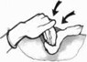
2. Tourniquet. Excellent method of bleeding control for any limb wounds. We do not carry combat tourniquets in our ERs so you will have to improvise with a blood pressure cuff manually inflated to 300mmHg or until the distal pulses disappear. Prolonged tourniquet use can result in ischemic damage to distal tissue but the immediate benefit to blood loss reduction makes it a worthwhile intervention. Mark the time you have started the tourniquet application. Ideally, leave it on for 2 hours or less but can leave it for up to 3-4 hours if necessary.
3. Foley catheter. Balloon tamponade is a well recognized surgical blood loss control technique. It is particularly useful for deep junctional hemorrhage (axilla, neck and groin) that are inaccessible to both direct pressure and tourniquets. 93% success with achieving local tamponade in the largest trauma case series of this technique. Insert the Foley as far as it will go, inflate the balloon and clamp the tube to prevent blood loss through it.

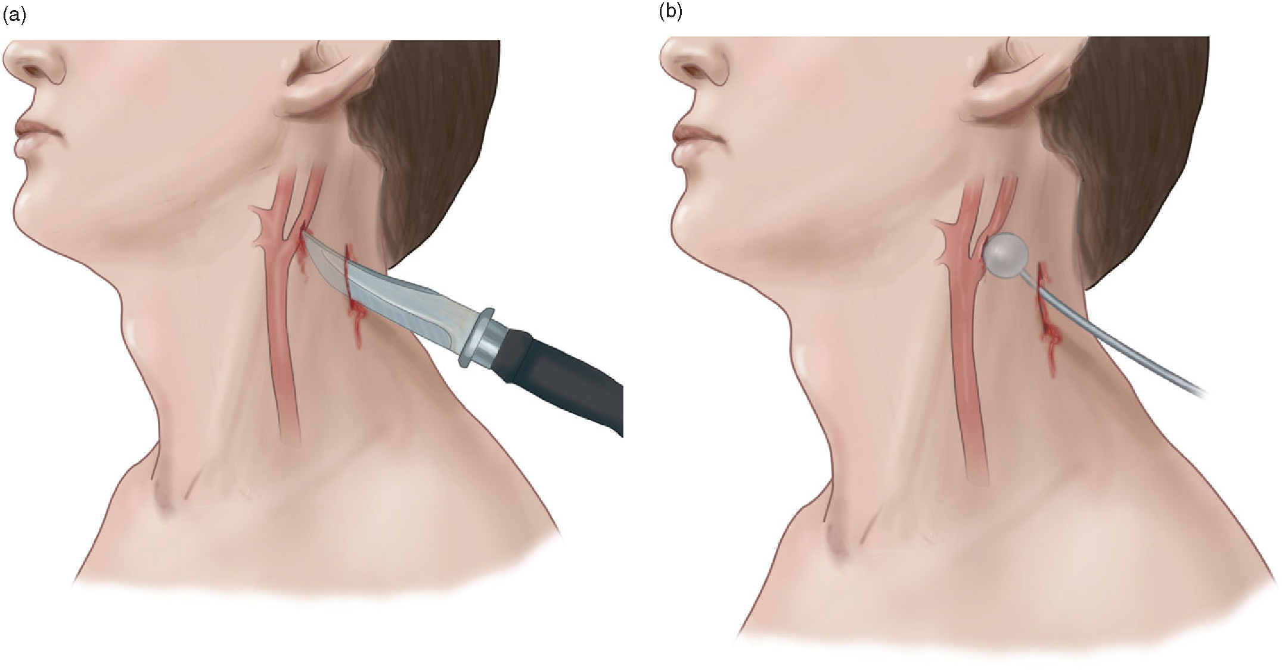

**Scalp injuries**. Bleed like stink, but luckily are fairly easy to stop- direct pressure, and if that does not work, figure of 8 stitch with the largest curved needle that you can find. If you have ever heard that “hypotension is never from a head injury”, that applies to a brain hemorrhage only, people will and do exasanguinate from scalp wounds.

**Neck**: Rapidly explore with forceps- if there is no penetration of the platysma (the big sheath-like muscle beneath the subcutaneous layer), dress it an carry on, it is of no consequence. If it does penetrate platysma, assume that the carotid and the IJ are damaged and immediately apply pressure or Foley and prepare your airway kit in case the hematoma becomes expansive and attempts to occlude the airway. Also assume that the trachea, bronchus and esophagus have been injured (regardless whether it is zone 1,2 or 3) but since you can't do anything about those, simply avoid putting an NG tube in someone with a neck stab in case esophagus has been penetrated

**Chest**: If there is an injury that penetrates into the chest cavity (ie, through the intercostal muscle layer), immediately put a chest tube- there WILL be hemo if not hemo/pneumo on that side. If the path crosses mid line, assume that great vessels, bronchi and spine have been injured- again you can't really do anything about it, just expect more rapid exsanguination+/- spine injury. If there is more then 1-1.5L of blood coming from the tube (and you are not having trouble ventilating the patient), can consider clamping it.

After the chest tube do the clinical and/or U/S assessment for pericardial blood and signs of tamponade. Pericardiocentesis is an option if clear signs of tamponade exist and no other interventions have worked to stabilize the patient

**Abdomen**: If it is a knife injury, it sometimes does not penetrate peritoneal fascia. Under local anesthesia, explore with forceps. If you are sure there is no penetration of the fascia, can close the wound, give antibiotics and discuss with a surgeon whether they want further imaging. If there is penetration of the fascia, pack the entry wound, use Tranexamic acid if hypotensive, prepare to transfuse blood and transfer out as soon as possible. A positive FAST indicates damage to solid viscus organs, but a negative FAST does not rule out hollow viscus injury. All gunshot wounds to the abdomen will need a transfer and surgical assessment.

**Pelvis**: two scenarios here- a bullet that penetrates from the front and tears up the posterior venous plexus, or a direct penetrating injury to large blood vessels in the pelvic region, aka the iliacs and the femoral arteries and veins. In the first case, you can't do much except Tranexamic acid, prepare to transfuse and transfer out. In the second, use direct pressure if the wound is accessible to it, Foley tamponade if it is not.

**Extremities:** immediate dressing and direct pressure and if that does not stop the bleed, a proximal tourniquet

**Back:** a log roll looking primarily for exist wounds and any hidden back/flank trauma. Remember, the number of entry plus exit wounds should be an even number. If not, you have a retained bullet.

***Foley?***Place the Foley with significant truncal penetrating injury as even microscopic hematuria can signify kidney injury in that setting

**Breathing**

Still breathing, any temporizing measures keeping up the sats?- keep up the good work.

Either not the case? - secure the airway. You can spend the time at this point for a proper RSI as all the life threatening hemorrhage should have been dealt with by now.

**Exposure**

COVER THE PATIENT UP AND APPLY A BAER HUGGER IF AVAILABLE. Remember hypothermia and the deadly triad? It still applies.

**Notes on fluids and transfusion.**

Disclaimer: This is a hugely controversial topic with no settled “truth”, this is just one guy's reading of the evidence and its evolution.

The standard ATLS teaching is to give at least 2L of crystalloids then packed PRBCs to a bleeding/hypotensive patient and keep the fluid/blood coming until BP normalizes and tachycardia disappears. This came mostly from animal studies in the 70s and 80s that used a model where a blood vessel would be cannulated, the animal bled, and the vessel would then be clamped. In such a model, more fluid meant more fluid pressure and better resuscitation.

Once the obvious realization came that this is not the way that actual traumatic injuries behave, they switched in the 90s to models that allowed for ongoing bleeding. With such a model, these realizations were made:

1. large volume resuscitation meant dramatically more blood loss
2. large volume crystalloid resuscitation prevented the body from making an effective clot over the injury, leading instead to a weak, gelatinous mess that could not hold off further bleeding.
3. The body is only usually able to make one, primary, clot. If that clot is lost, making of the second one was highly unlikely.

Around this time, researchers in Houston published a landmark study that showed that in patients with isolated penetrating chest trauma, giving people no fluids or blood whatsoever before they went into the OR led to significant mortality benefit. The age of permissive hypotension was born. (Reborn, actually. Permissive hypotension was the norm in WWII resuscitation, but was replaced with high volume crystalloid resuscitation around the time of Vietnam, for reasons that are not particularly clear to me).

Also at this time, the concept of damage control surgery was born. The early ATLS focus on “golden hour” survival meant that patients were rushed into the OR and the surgeons would try to fix all their injuries there and then. Unfortunately, the trauma of these lengthy surgeries as well as the previous release of inflammatory cytokines due to the primary trauma (with all the negative effects of fluid extravasation, endothelial and clotting factor dysfunction) meant that many patients succumbed to the deadly triad of hypothermia-acidosis-coagulopathy and died in the OR or shortly after in the ICU.

The damage control method replaced the definitive surgical treatment of injuries with simply ligating bleeding vessels and packing the bleeding capillary wounds internally, after which the patient would be sent to ICU for prolonged secondary resuscitation. The lengthy definitive repair would only take place once all the biochemical and physiologic markers stabilized and the “cytokine storm” of the trauma abated.

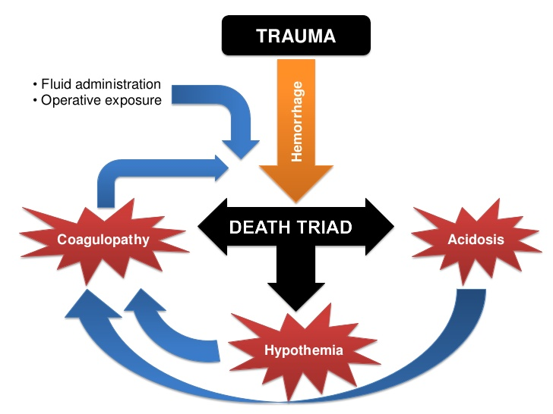

rebelem.com

It was the US military that picked up these particular balls and ran with them. Wars in Iraq and Afghanistan allowed them to try the new methods on a large scale.

There, an ideal resuscitation meant that a wounded soldier would have immediate hemorrhage control preformed by combat medics using tourniquets and coagulation powders. If the patient was alert, no fluid resuscitation would typically take place in order to protect the primary blood clot. If the patient was not alert, or unconscious, or had BP in the boots (MAP<50), a small bolus (~100cc) of 7.5% or 9% hypertonic saline would be given to boost the BP until the patient reached the surgical centre, which would be within the hour or two owning to helicopter extraction. There, immediate damage control surgery would be performed and instead of blood products, fresh warmed whole blood would be judiciously given from previously blood typed “walking donors”, (IE other soldiers) or by auto transfusion of wounded' own collected blood.

This approach (together with much improved body armour) led to a staggering increase in survival of wounded soldiers. Of course, since it was such a multifactorial approach, they are still trying to tease out which particular parts were the lifesaving ones. On the civilian side, the picture is much murkier because of lack of fresh whole blood availability, long transfer delays, lack of trauma OR availability, patient medical comorbidities etc. In particular, the trials of permissive hypotension in “all comers” trauma has not demonstrated a 30 day mortality benefit yet (although it has demonstrated less mortality at 24hrs and much less use of the blood products), but I think that some general conclusions can be reached that are useful to a rural ED practitioner.

1. Resuscitation with copious amount of crystalloids, especially normal saline is bad. It exacerbates bleeding, weakens the primary clot, dilutes the coagulation factors and, in the case of normal saline, leads to hypercholermic acidosis due to hypertonic concentration of Cl compared to blood (154 meq vs usually 105 meq in blood). It does not serve the patient well to receive litres and litres of crystalloid in order to make his BP 120/80 in the ED, only to have him succumb to the lethal triad in the OR hours later.
2. If blood products are needed, trying to mimic whole blood sooner rather then later is probably a good thing. In reality, most rural EDs only store 2-4 unit of O negative blood and perhaps 1-2 units of FFP. Platelets and cryoprecipitate are usually not available, so how closely you can mimic whole blood is largely dictated by your locale.
3. As long as the patient is not actively exsanguinating and is mentating well (IE the brain is not hypoperfused, and/or there is no intracranial hemorrhage), aim for MAP between 50 and 65. If there are concerns about intracranial hemorrhage, aim for MAP of 75 and sBP>90

With these things in mind, our approach is this:

If the patient is alert, oriented, has no sign of intracranial hemorrhage and the MAP is at 50-65 or above, I leave things be, as long as the patient has no signs of BP dropping (indicating lack of primary clot) or there are other signs of active bleeding, such as a visible penetrating bleeding wound, ongoing chest tube drainage or increasing intrabdominal free fluid on the U/S exam.

If any of the above is not true, I give one or two 500cc boluses of Ringer's Lactate (less chloride then Normal Saline, thus less acidosis).

If those do not fix the situation, I give 1 unit of PRBC.

If that does not fix the situation, I am switching to a potential “massive transfusion” protocol. This normally means 8-10 unit PRBC requirement in 24 hrs but since I won't keep this patient for 24 hrs, I need to make this decision much sooner, and I would rather overcall it then undercall it. The ABC score is a useful tool here.

***ABC Score:***

* + 1. Pentrating Trauma
    2. sBP <90 in ED
    3. HR> 120 depsite pain control
    4. Positive FAST exam

Score of 2 or more indicates likely need for massive transfusion.

If we have more then just the 2-4 O neg PRBC units available, we will be mobilizing those blood bank reserves STAT.

***Blood Products Delay***

Type Specific (ABO/Rh): 5-10 min

Cross match: (ABO/Rh+ minor antibodies): 45-60 min

FFP: 25-45 minute, depending on the available thawing method

With these resources mobilized, we will give the 2nd PRBC unit, and if that has not fixed the situation, we will start infusing the FFP and whatever else we have available (ie FFP and platelets), aiming for a 1:1:1 ratio; although a 2:1:1:1 ratio is acceptable as well if you are constrained by the available supply.

If we do not have these extra resources available, we will packing into an ambulance with the patient ASAP and taking the 1-3 remaining O- PRBC units with us and beseeching the Almighty for help. All the blood we give will be given warmed through a blood warmer if at all possible.

The caveat with this restricted fluid resuscitation approach is that it hinges on availability of damage control surgery reasonably soon, IE within a few hours. There are several studies that show that prolonged under-resuscitation, as evidenced by persistent lactate, base deficit, etc, leads to increased mortality, so if you and the patient are many hours or even days away from an OR (due to snow storms, or distance), resuscitate to normal BP and normal lactate, HCO3 and pH, if you can.

**Special cases**

1. Young/fit people. They can increase the cardiac output by a factor of 6 (HR by 3, contractility by about 2), so can tolerate massive blood loss before hypotension becomes apparent. In the absence of “uppers” such as cocaine and meth, beware of tachycardia that persists after the pain and anxiety have been fixed, even if the BP is normal
2. Old people. Much less ability to upregulate cardiac output to compensate for blood loss, making them “crash” sooner. Also, many are hypertensive at baseline. Finally, many are on heart-limiting drugs such as beta blockers and non-DHP Ca channel blockers (Diltiazem and Verapamil). Thus, a “normal” BP might be quite hypotensive for someone who usually runs at 160/90, and his HR of 80 might be from his Metoprolol, rather then lack of bleeding.
3. Drug addicts, especially narcotics. Might be quite resistant to usual anxiolysis and analgesic drugs (Fentanyl, Propofol and Benzos). Luckily, there is no cross reactivity to Ketamine, so use that until they are happily (but lightly) dissociated and not causing trouble or in pain.
4. Burns. Intubate airway burns right away, preferably with video laryngoscopy and a double setup for surgical cric if your first pass attempt fails. Escharotomy for cicrumferential scars. Tetanus and Ancef for everyone. Lots of fluids, Parkland formula being the mainstay: 4cc/kg/percent of 2nd or 3rd degree burn in 24hrs, first half given over the first 8 hrs. Stay away from Normal Saline as it will surely cause hyperchloremic acidosis in such quantities and go for the more isotonic Lactated Ringer's. Use Rule of 9s to estimate burn size, or 1 palm size equals 1%.
5. Pregnant women. Ignore the fetus- what's best for the mother is best for it, too. Put the mother in the left lateral decubitus position if possible to decompress the IVC and improve the venous return. If the mother dies, the fetus is 24+ weeks and you have obs/gyne right there, they can attempt a perimortem C-section but it usually ends badly.

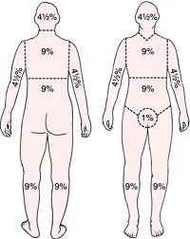

**Meds:**

Induction

Ketamine is going to be out mainstay induction drug. First, it can be given in dissociating doses, facilitating our Awake intubation. Second, it does not produce the same central apnea and pharyngeal tone collapse that other induction drugs do. It has a very high LD50, making it virtually impossible to poison the patient with it. Finally, it is not associated with post intubation hypotension, like some of the other agents. Contrary to popular opinion, it is safe to give in head-injured patients.

Ketamine.

1. Dissociation: 20-100mg IV. 20 mg at a time, q2-3 min, until patient is happy. Double the doses if giving IM
2. Induction 100mg IV for normal size person, 150mg IV for big person.
3. Ongoing sedation: 75-100mg/hr IV drip

Paralysis

We will always use Rocuronium (Roc). Succynilcholine (Sux) has contraindications. Roc does not. Sux can produce bradycardia. Roc does not. Sux produces fasciculations that can increase ICP. Roc does not. Sux produces hyperkalemia. Roc does not. At doses of 1.2mg/kg, they both produce equally good intubation conditions. Both of them have duration of action that is longer than the typical apneic desaturation time of a patient. Thus, there is no real benefit to Sux, except in the very rare cases of a previously known Roc allergy (in that case, dose of Sux is the same as Roc-100mg)

Rocuronium

1. Induction: 100mg. This should last 30-45 min
2. Maintenance of paralysis: 50mg whenever the patient starts moving

Maintenance of sedation

Of the agents below, Fentanyl is not a true sedative, but rather a pain killer with sedative properties at high doses. However, adequate pain control with it can significantly reduce the sedative doses of other agents needed. Thus, our usual approach is Fentanyl drip+ a sedative top up until the patient does not exhibit signs of agitation (movement if not paralyzed; heart rate and BP elevation +/- tearing if paralyzed)

1. Ketamine 75-100mg/hr
2. Fentanyl 100-400mcg/hr

Adjuncts

The only adjunct we will use is Phenyelphrine to deal with a peri or post intubation hypotension. Lidoicaine and Fentanyl for traumatic brain injury have really weak evidence base and are complicated to remember and use if TBI intubations are not your daily reality. Atropine for drying out secretions takes 15-30 min to work, which is usually not a useful timeframe for a sick patient needing an ETT tube.

1. Phenylephrine. Comes in 10mg vials. Instill into a 100cc NS bag. This gives us a concentration of 100mcg/cc. Give 1-3cc at a time, or drip at 1-3cc/minute.

Increased ICP

Mannitol is the drug we will use to manage increased ICP in conjunction with head of bed elevation and moderate hyperventilation. Mannitol is a very potent osmotic diuretic so DO NOT give it in a hypotensive patient or a patient that is actively bleeding elsewhere in the body.

* 1. Mannitol: 0.25-1gr/kg IV

Selected References

1. ATLS Manual, 5th edition
2. trauma.org
3. Hypotensive resuscitation during active hemorrhage: Impact on in-hospital mortality.Dutton RP, MacKenzie CF, Scalea TM,   
   R Adams Cowley Shock Trauma Center, and the Departments of Anesthesiology and Surgery,   
   University of Maryland School of Medicine, Baltimore, Maryland.[J Trauma 2002 June;52(6):1141-1146](http://ipsapp002.lwwonline.com/content/getfile/2281/94/20/abstract.htm#_blank)
4. [Holmes JF](mailto:jfholmes@ucdavis.edu), Sakles JC, Lewis G, Wisner DH.   
   Division of Emergency Medicine, University of California, Davis, School of Medicine,   
   Sacramento, CA 95817-2282, USA.[Academic Emergency Medicine 2002 Apr;9(4):267-74](http://www.aemj.org/cgi/content/abstract/9/4/267#_blank).
5. Continuous fluid resuscitation and splenectomy for treatment of uncontrolled hemorrhagic shock after massive splenic injury. Abu-Hatoum O, Bashenko Y, Hirsh M, Krausz MM,   
   Department of General Surgery and the Laboratory for Shock and Trauma Research,   
   Rambam Medical Center, and the Bruce Rappaport Faculty of Medicine,   
   Technion-Israel Institute of Technology, Haifa, Israel. [J Trauma 2002 Feb;52:253-258](http://ipsapp002.lwwonline.com/content/getfile/2281/90/9/abstract.htm#_blank)
6. Bickell WH, Wall MJ Jr, Pepe PE, Martin RR, Ginger VF, Allen MK, Mattox KL. Immediate versus delayed fluid resuscitation for hypotensive patients with penetrating torso injuries. N Engl J Med. 1994 Oct 27;331(17):1105-9.
7. Mapstone J, Roberts I, Evans P. Fluid resuscitation strategies: a systematic review of animal trials. J Trauma. 2003 Sep;55(3):571-89.
8. Sapsford W. Should the ‘C’ in ‘ABCDE’ be altered to reflect the trend towards hypotensive resuscitation? Scand J Surg. 2008;97(1):4-11; discussion 12-3. Review. PubMed PMID: 18450202.
9. Wiles MD. Blood pressure management in trauma: from feast to famine? Anaesthesia. 2013 May;68(5):445-9. doi: 10.1111/anae.12249. Epub 2013
10. Brivet F., Bernardin M., Dormont J. [Hyperchloremic acidosis in metabolic acidosis with anion gap excess. Comparison with diabetic ketoacidosis]. Presse Med 1991;
11. Burdett E., Roche T., Donnelly T., Moulding R., Mythen M. Saline-based fluid resuscitation is associated with metabolic acidosis in surgical patients. Eur J Anaesthesiology 2003; in press.
12. Astrup P., Jorgensen K., Siggaard-Andersen O., et al. Acid-base metabolism: a new approach. Lancet 1960;**1**:1035–9.
13. Neugebauer E., Zander R. Clinical relevance of base excess and lactate concentration. Anasthesiol Intensivmed Notfallmed Schmerzther 2002; **37**:341–2.
14. Hyperchloremic Acidosis: Pathophysiology and Clinical Impact.Edward Burdett MA, MB BS, MRCP, Research Fellow1, Antony M. Roche MB ChB, FRCA, MMed (Anaes), Research Fellow1 andMichael G. Mythen MB BS, FRCA, MD, Portex Professor. Transfusion Alternatives in Transfusion Medicine. [Volume 5, Issue 4,](http://onlinelibrary.wiley.com/doi/10.1111/tatm.2003.5.issue-4/issuetoc)pages 424–430, October 2003
15. Hypotensive resuscitation strategy reduces transfusion requirements and severe postoperative coagulopathy in trauma patients with hemorrhagic shock: preliminary results of a randomized controlled trial.[Morrison CA](http://www.ncbi.nlm.nih.gov/pubmed?term=Morrison%20CA%5BAuthor%5D&cauthor=true&cauthor_uid=21610356)1, [Carrick MM](http://www.ncbi.nlm.nih.gov/pubmed?term=Carrick%20MM%5BAuthor%5D&cauthor=true&cauthor_uid=21610356), [Norman MA](http://www.ncbi.nlm.nih.gov/pubmed?term=Norman%20MA%5BAuthor%5D&cauthor=true&cauthor_uid=21610356), [Scott BG](http://www.ncbi.nlm.nih.gov/pubmed?term=Scott%20BG%5BAuthor%5D&cauthor=true&cauthor_uid=21610356), [Welsh FJ](http://www.ncbi.nlm.nih.gov/pubmed?term=Welsh%20FJ%5BAuthor%5D&cauthor=true&cauthor_uid=21610356), [Tsai P](http://www.ncbi.nlm.nih.gov/pubmed?term=Tsai%20P%5BAuthor%5D&cauthor=true&cauthor_uid=21610356), [Liscum KR](http://www.ncbi.nlm.nih.gov/pubmed?term=Liscum%20KR%5BAuthor%5D&cauthor=true&cauthor_uid=21610356), [Wall MJ Jr](http://www.ncbi.nlm.nih.gov/pubmed?term=Wall%20MJ%20Jr%5BAuthor%5D&cauthor=true&cauthor_uid=21610356), [Mattox KL](http://www.ncbi.nlm.nih.gov/pubmed?term=Mattox%20KL%5BAuthor%5D&cauthor=true&cauthor_uid=21610356). [J Trauma.](http://www.ncbi.nlm.nih.gov/pubmed/21610356) 2011 Mar;70(3):652-63
16. Optimal Use of Blood Products in Severely Injured Trauma Patients. [John B. Holcomb](http://www.ncbi.nlm.nih.gov/pubmed/?term=Holcomb%20JB%5Bauth%5D). [Hematology Am Soc Hematol Educ Program. 2010; 2010: 465–469.](http://www.ncbi.nlm.nih.gov/entrez/eutils/elink.fcgi?dbfrom=pubmed&retmode=ref&cmd=prlinks&id=21239837#_blank)
17. Turner J, Nicholl J, Webber L, Cox H, Dixon S, Yates D. A randomised controlled trial of prehospital intravenous fluid replacement therapy in serious trauma. *Health Technology Assessment (Winchester, England)* 2000
18. emcrit.org
19. Holcomb, J.B., del Junco, D.J., Fox, E.E. et al. The Prospective, Observational, Multicenter, Major Trauma Transfusion (PROMMTT) study. *JAMA Surg* 2013; 148: 127–136.
20. Holcomb JB, Tilley BC, Baraniuk S, et al. Transfusion of plasma, platelets, and red blood cells in a 1:1:1 vs a 1:1:2 ratio and mortality in patients with severe trauma: the PROPPR randomized clinical trial. *JAMA* 2015;313:(5)471-82.
21. Timothy C. Nunez, MD, Igor V. Voskresensky, MD, Lesly A. Dossett, MD, MPH, Ricky Shinall, BS, William D. Dutton, MD, and Bryan A. Cotton, MD. Early Prediction of Massive Transfusion in Trauma: Simple as ABC (Assessment of Blood Consumption)? 01-03-15_2009-j-trauma.
22. Pracy JP, Brennan L, Cook TM. Surgical intervention during a Can't intubate Can't Oxygenate (CICO) Event: Emergency Front-of-neck Airway (FONA)? British journal of anaesthesia. 2016. PMID: [27646054](http://www.ncbi.nlm.nih.gov/pubmed/27646054#_blank)
23. Cook TM, Woodall N, Harper J, Benger J, . Major complications of airway management in the UK: results of the Fourth National Audit Project of the Royal College of Anaesthetists and the Difficult Airway Society. Part 2: intensive care and emergency departments. British journal of anaesthesia. 106(5):632-42. 2011. PMID: [21447489](http://www.ncbi.nlm.nih.gov/pubmed/21447489#_blank)
24. [Morrison CA](https://www.ncbi.nlm.nih.gov/pubmed/?term=Morrison%20CA%5BAuthor%5D&cauthor=true&cauthor_uid=21610356)1, [Carrick MM](https://www.ncbi.nlm.nih.gov/pubmed/?term=Carrick%20MM%5BAuthor%5D&cauthor=true&cauthor_uid=21610356), [Norman MA](https://www.ncbi.nlm.nih.gov/pubmed/?term=Norman%20MA%5BAuthor%5D&cauthor=true&cauthor_uid=21610356), [Scott BG](https://www.ncbi.nlm.nih.gov/pubmed/?term=Scott%20BG%5BAuthor%5D&cauthor=true&cauthor_uid=21610356), [Welsh FJ](https://www.ncbi.nlm.nih.gov/pubmed/?term=Welsh%20FJ%5BAuthor%5D&cauthor=true&cauthor_uid=21610356), [Tsai P](https://www.ncbi.nlm.nih.gov/pubmed/?term=Tsai%20P%5BAuthor%5D&cauthor=true&cauthor_uid=21610356), [Liscum KR](https://www.ncbi.nlm.nih.gov/pubmed/?term=Liscum%20KR%5BAuthor%5D&cauthor=true&cauthor_uid=21610356), [Wall MJ Jr](https://www.ncbi.nlm.nih.gov/pubmed/?term=Wall%20MJ%20Jr%5BAuthor%5D&cauthor=true&cauthor_uid=21610356), [Mattox KL](https://www.ncbi.nlm.nih.gov/pubmed/?term=Mattox%20KL%5BAuthor%5D&cauthor=true&cauthor_uid=21610356). Hypotensive resuscitation strategy reduces transfusion requirements and severe postoperative coagulopathy in trauma patients with hemorrhagic shock: preliminary results of a randomized controlled trial. [J Trauma.](https://www.ncbi.nlm.nih.gov/pubmed/21610356/) 2011 Mar;70(3):652-63
25. Ball, C. Current management of penetrating torso trauma: nontherapeutic is not good enough anymore. [Can J Surg](https://www.ncbi.nlm.nih.gov/pmc/articles/PMC3968212/). 2014 Apr; 57(2): E36–E43
26. [Ball CG](https://www.ncbi.nlm.nih.gov/pubmed/?term=Ball%20CG%5BAuthor%5D&cauthor=true&cauthor_uid=21307730)1, [Wyrzykowski AD](https://www.ncbi.nlm.nih.gov/pubmed/?term=Wyrzykowski%20AD%5BAuthor%5D&cauthor=true&cauthor_uid=21307730), [Nicholas JM](https://www.ncbi.nlm.nih.gov/pubmed/?term=Nicholas%20JM%5BAuthor%5D&cauthor=true&cauthor_uid=21307730), [Rozycki GS](https://www.ncbi.nlm.nih.gov/pubmed/?term=Rozycki%20GS%5BAuthor%5D&cauthor=true&cauthor_uid=21307730), [Feliciano DV](https://www.ncbi.nlm.nih.gov/pubmed/?term=Feliciano%20DV%5BAuthor%5D&cauthor=true&cauthor_uid=21307730). A decade's experience with balloon catheter tamponade for the emergency control of hemorrhage. [J Trauma.](https://www.ncbi.nlm.nih.gov/pubmed/21307730) 2011Feb;70(2):330-3.
27. Porter, JM et al. DRE for trauma: Does every patient need one? Am Surg 2001May 67(5), 438-41
28. Crashingpatient.com- IO Primer
29. [Rotheray KR](https://www.ncbi.nlm.nih.gov/pubmed/?term=Rotheray%20KR%5BAuthor%5D&cauthor=true&cauthor_uid=21787740)1, [Cheung PS](https://www.ncbi.nlm.nih.gov/pubmed/?term=Cheung%20PS%5BAuthor%5D&cauthor=true&cauthor_uid=21787740), [Cheung CS](https://www.ncbi.nlm.nih.gov/pubmed/?term=Cheung%20CS%5BAuthor%5D&cauthor=true&cauthor_uid=21787740), [Wai AK](https://www.ncbi.nlm.nih.gov/pubmed/?term=Wai%20AK%5BAuthor%5D&cauthor=true&cauthor_uid=21787740), [Chan DY](https://www.ncbi.nlm.nih.gov/pubmed/?term=Chan%20DY%5BAuthor%5D&cauthor=true&cauthor_uid=21787740), [Rainer TH](https://www.ncbi.nlm.nih.gov/pubmed/?term=Rainer%20TH%5BAuthor%5D&cauthor=true&cauthor_uid=21787740), [Graham CA](https://www.ncbi.nlm.nih.gov/pubmed/?term=Graham%20CA%5BAuthor%5D&cauthor=true&cauthor_uid=21787740).What is the relationship between the Glasgow coma scale and airway protective reflexes in the Chinese population? Resuscitation 2011
30. [Thompson DO](https://www.ncbi.nlm.nih.gov/pubmed/?term=Thompson%20DO%5BAuthor%5D&cauthor=true&cauthor_uid=21803448)1, [Hurtado TR](https://www.ncbi.nlm.nih.gov/pubmed/?term=Hurtado%20TR%5BAuthor%5D&cauthor=true&cauthor_uid=21803448), [Liao MM](https://www.ncbi.nlm.nih.gov/pubmed/?term=Liao%20MM%5BAuthor%5D&cauthor=true&cauthor_uid=21803448), [Byyny RL](https://www.ncbi.nlm.nih.gov/pubmed/?term=Byyny%20RL%5BAuthor%5D&cauthor=true&cauthor_uid=21803448), [Gravitz C](https://www.ncbi.nlm.nih.gov/pubmed/?term=Gravitz%20C%5BAuthor%5D&cauthor=true&cauthor_uid=21803448), [Haukoos JS](https://www.ncbi.nlm.nih.gov/pubmed/?term=Haukoos%20JS%5BAuthor%5D&cauthor=true&cauthor_uid=21803448). Validation of the Simplified Motor Score in the out-of-hospital setting for the prediction of outcomes after traumatic brain injury. Ann Em Med 2012
31. [Steven M. Green](javascript:void(0);), Cheerio, Laddie! Bidding Farewell to the Glasgow Coma Scale. Ann Em Med 2012

# [Perry JJ](https://www.ncbi.nlm.nih.gov/pubmed/?term=Perry%20JJ%5BAuthor%5D&cauthor=true&cauthor_uid=18425883)1, [Lee JS](https://www.ncbi.nlm.nih.gov/pubmed/?term=Lee%20JS%5BAuthor%5D&cauthor=true&cauthor_uid=18425883), [Sillberg VA](https://www.ncbi.nlm.nih.gov/pubmed/?term=Sillberg%20VA%5BAuthor%5D&cauthor=true&cauthor_uid=18425883), [Wells GA](https://www.ncbi.nlm.nih.gov/pubmed/?term=Wells%20GA%5BAuthor%5D&cauthor=true&cauthor_uid=18425883).Rocuronium versus succinylcholine for rapid sequence induction intubation. Cochrane Database Review 2015

# Daniel G. Ostermayer & Marianne Gausche-Hill. [Supraglottic Airways: The History and Current State of Prehospital Airway Adjuncts](http://www.tandfonline.com.proxy.queensu.ca/doi/abs/10.3109/10903127.2013.825351). [Prehospital Emergency Care](http://www.tandfonline.com.proxy.queensu.ca/toc/ipec20/18/1)Vol. 18 , Iss. 1,2014

# Joseph R.Brimacombe, Alison Berry. The incidence of aspiration associated with the laryngeal mask airway: A meta-analysis of published literature. Journal of Clinical Anesthesia, 2014

1. [Su YC](https://www.ncbi.nlm.nih.gov/pubmed/?term=Su%20YC%5BAuthor%5D&cauthor=true&cauthor_uid=21897263)1, [Chen CC](https://www.ncbi.nlm.nih.gov/pubmed/?term=Chen%20CC%5BAuthor%5D&cauthor=true&cauthor_uid=21897263), [Lee YK](https://www.ncbi.nlm.nih.gov/pubmed/?term=Lee%20YK%5BAuthor%5D&cauthor=true&cauthor_uid=21897263), [Lee JY](https://www.ncbi.nlm.nih.gov/pubmed/?term=Lee%20JY%5BAuthor%5D&cauthor=true&cauthor_uid=21897263), [Lin KJ](https://www.ncbi.nlm.nih.gov/pubmed/?term=Lin%20KJ%5BAuthor%5D&cauthor=true&cauthor_uid=21897263). Comparison of video laryngoscopes with direct laryngoscopy for tracheal intubation: a meta-analysis of randomised trials. [Eur J Anaesthesiol.](https://www.ncbi.nlm.nih.gov/pubmed/21897263) 2011 Nov;28(11):788-95.

.